Maryke Adrienne : Shopping List Food Technology and Hospitality (Monday - Friday)

Week 4 ending: 15 May
Meat  Monday :  Tuesday:  2kg + 2kg Beef Mince  4 + 4 x sausage meat rolls  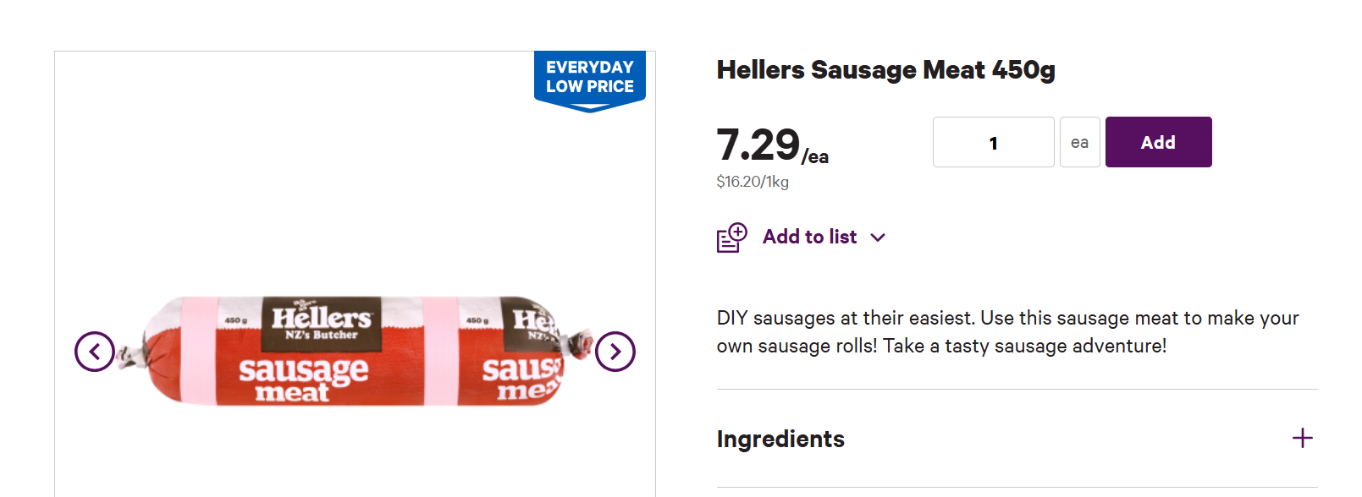  Wednesday :  L3: 1kg Bacon rashers (Streaky)  Juniors: 1.2 kg Beef mince  Thursday:  600g Beef Mince  Friday: | Dairy & Pastry  Monday :  2L Double cream (Full cream) - in freezer  2L Milk Full cream  Tuesday:  9+9 eggs (18 eggs)  2 + 2 x puff pastry rolled sheet packet Pams (4 packets.)  Wednesday :  L3:  3 x 300ml cream  1 large tub pesto  Junior:  2L of blue milk  24 eggs  1kg Pizza Blend cheese  Thursday:  1L of blue milk  10 eggs  500g Pizza blend cheese  Friday:
Dry Ingredients  3 x 400g packet of Penne pasta (multi colour if possible) | Tinned Food  Monday :  Tuesday:  Wednesday :  Thursday:  Friday:
Cleaning Products  Dishwashing liquid  Washing powder  Dishwasher tablets  Kitchen paper towel  Jik  Jif  Oven cleaner  Nappy San  Brown take away bags (2 box) -ordered from trents | Fruit and Vegetables  Monday :  Frozen Berries 2kg -in freezer  2 packets of mint (fresh)  Tuesday:  Wednesday :  Junior:  12 Medium Potatoes (10kg bag)  2 bunches of spring onion  6 medium Brown onions (or 12 small)  2 bunches of spring onion  Thursday:  L3:  6 garlic cloves  6 brown onions  600g White button mushrooms  Fresh basil 2 x pakets  St M:  6 Medium Potatoes (5kg bag)  3 medium Brown onions (or 6 small)  1 bunches of spring onion  Friday:  18 medium Potatoes  4 Red onion  2 bunches of parsley
Other
3 kg castor sugar
1 bottle lemon juice
Cooking oil (3L to refill bottles if needed)
Salt
Black Pepper
Mixed herbs
1 Bottle BBQ sauce
1 Bottle Tomato sauce
6 packets of sesame seeds (3 per class)
2 kg sugar
2 L white Vinegar
1 Tub crushed garlic
1 Large tub Mayo
1 Bottle of Olive oil
1 Bottle Vanilla extract
12 x 4g Gelatine powder (48g)

Qqq

AwQr0

